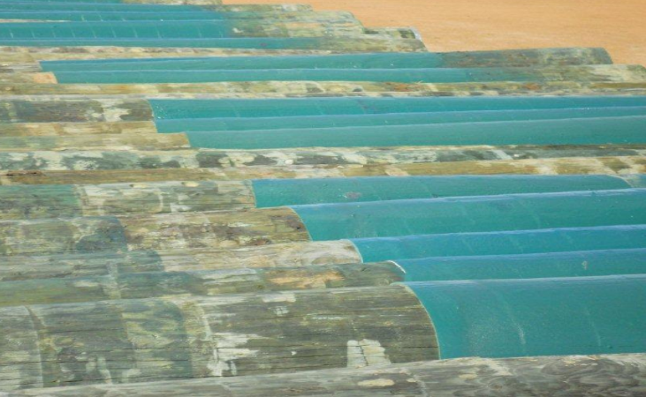
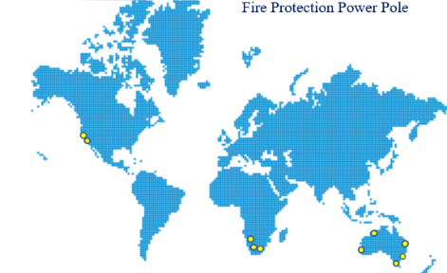

Project:

Western Power Poles

Location:

Perth Western Australia

Project Overview:

Nukote Australia Pty. Ltd and Nukote Coating Systems International (USA), initiated trials with Koppers Wood Products (KOP NYSE $41.10) to develop a fire rated elastomeric coating to address new Australian legislation for wooden power distribution poles. The new legislation was initiated following the Black Saturday tragedy in Australia.
Working in conjunction with the pole supplier, the client and testing laboratories, Nukote designed a product and application standard for fire proofing and protection of wooden poles. After significant testing and trials, the system was accepted by the client and supplier. This system has been in use in Western Australia for more than four years and has become the standard in geographic locations where brush or veld fires are problematic.

Similar project locations

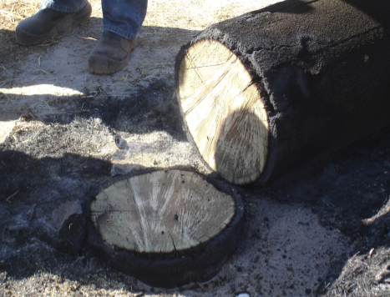
Project Summary:
Black Saturday was an event where a series of bush fires were burning across the Australian state of Victoria/NSW/WA starting on Saturday, 7 February 2009.
The fires occurred during extremely dry weather conditions and resulted in Australia's highest ever loss of life from bushfire; 173 people died and 414 were injured as a result of the fires. 400 individual fires were recorded on 7 February. Following the events of 7 February 2009 and its aftermath, that day has become widely referred to as Black Saturday.
Two months after the black Saturday fires it was established that the root cause was from a small bush fire that burned down a series of wooden power transmission poles shorting out the electrical transmission lines they were supporting, causing the fires to propagate into a massive fire storm.

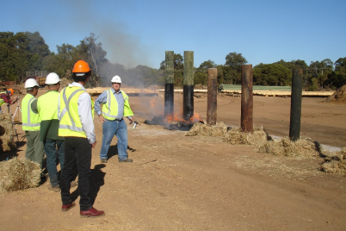

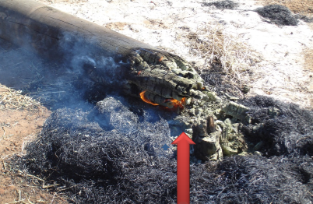

Competitor product failed in 30 min
Western Australian wooden power poles had been neglected for many years. Western Power initiated a big push to replace over 35,000 poles annually in the rural districts of Western Australia. New legislation was being sought to require that all poles needed to withstand a common veld or bushfire.
Nukote Australia, in conjunction with KOP, initiated in-house testing concurrently with CSIRO who were developing new test standards being for Veld fires, now referred to as ASTM D-2898-08, Method A, Augmented with UV. This test is also known as “Testing of Polymer Coated CCA-Treated Pine Poles in accordance with the ENA Pole Fire Test Method”.
Due to a lack of suitable native trees in Australia and the environmental issues surrounding creosote treated poles, the new environmental legislation included a requirement for all new poles to be only CCA treated. CCA treated poles are subject to “after burn testing” due to the poles ability, when CCA treated, to continue to burn even after the veld fire has passed by.

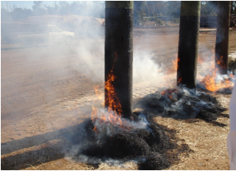
Nukote FR (FSP) as the only product tested for a double burn during the initial trials. Each in-house trial was monitored for wind speed and required to withstand an intense fire burn for 15-20 minutes @1000-1200°C then handle smouldering to determine after burn effect at the base of the poles.

Further testing included in house aged weathering to determine the applications ability to bridge timber checking and thermal cycling. After the poles had been coated they were subjected to kiln heating at 50°C for 48 hours, then removed and placed in winter conditions with rain to determine the aged weathering and thermal cycling capability.
It was determined at this stage that the moisture content could vary significantly. Often when too much moisture exists in most substrates outgassing and blistering can cause delamination and cracking. Minor formulation changes were made to Nukote FR increasing elongation to resolve this. This formula change in fact put Nukote FR on the product determination fit for purpose scale as follows:
Scale 1-10 for physical properties project specific:
Fire retardant capability: 10
Elongation (checking): 10
Aged weathering: 10
Application Speed: 10
Durability: 10
Aesthetics: 10
Price: 8

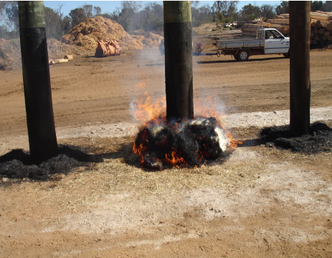

Further Testing
Further testing was implemented in Washington State at WFCI a world renowned fire testing lab.
Final 3rd party testing was initiated on October 12 2010 with Western Fire Centre Inc. Formal testing consisted of:

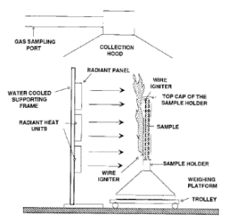
ASTM D-2898-08 standard practice for accelerated weathering for fire retardant treated wood for fire testing Method A. The specimens were subjected to twelve weeks accelerated weathering regime under ASTM D2898-08 “Standard practice for accelerated weathering of fire retardant treated wood for fire testing”. Method A, modified to permit ultraviolet (UV) exposure during the drying cycle.
ASTM E-1623 The fire test method is based on a modified version of the ASTM E1623 “Standard test method for determination of fire and thermal parameters of materials products, and systems using an Intermediate Scale Calorimeter” (ICAL) shown here in Figure 1.
CONCLUSIONS:
Upon inspection after termination of the replicate ENA pole fire tests, the Nukote CCA treated Radiata pine poles, coated with 3mm Nukote FR as identified in this report demonstrated fire test performance which can be deemed ‘Excellent’ in terms of the ENA rating system described in the referenced test method. The ENA pole fire test criteria (‘excellent’, ‘fair’, ‘poor’) were originally established on the basis of char depth (surface disruption) and the overall structural damage and effect on serviceability of the fire exposure conditions on wood poles.
The char depth of the replicate test specimens did not exceed 5 mm.

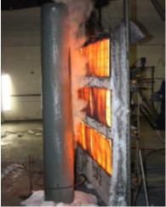

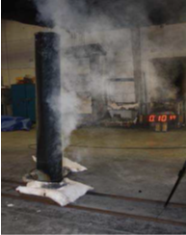

FR Application Implemented:
KOP / Western Power FR specification was awarded to Nukote in 2011 with additional new realizations of product capability.
Epoxy versions had been tried and tested in field applications but were problematic. The ability to coat year round, without weather conditions hampering curing, increased production capabilities from 50 poles per day to over 300. Increased production and reduced labor costs now made Nukote FR far more competitive in total cost comparisons.

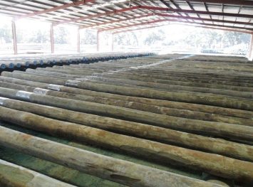
Handling and curing of the epoxy system required that the pole could not be handled or moved for 24 hours. The new FR version allowed front end loaders to remove and restack within minutes of application. FR products provide extreme durability, eliminating the requirement for additional protection and wrapping for much less durable Epoxy systems.
Higher UV resistance and superior aesthetic appearance gave Nukote FR a further edge on our competitors.
A green color was chosen to meet all public concerns.

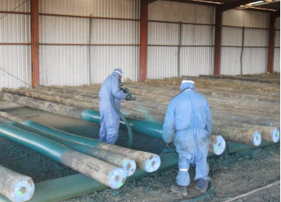

Conclusions:
Nukote FR application in full production using an application team of 4 personnel, complete between 200-400 poles per day in remote Western Australia. Nukote is now working with many utilities and consulting engineers throughout Australia, The United States and South Africa.
The application which began on wooden poles only has shifted to include concrete and steel poles which require full replacement in the same bush fire situation. KOP is now regaining better market realization to other utilities and local governments which are now shifting away from Steel and Concrete poles to CCA Pinus Radiata poles. We expect this growth to expand market penetration significantly for Nukote FR applications globally.
Our success with Nukote FR has created opportunities for Nukote to further develop many other applications, meeting the demand of the global power industry for newer technology with improved asset protection. Some of these opportunities are as follows:
Further market development into “other” applications; marine, building, oil and gas, petrochemical, for this unique product.
A new formulation has been in trial for several years combining Nukote FR with pesticide suspension for termite protection.
Further development of power distribution pole cross arm protection for fire suppression causing line ground failures
FR protection to Steel and Concrete poles
Intumescent -fire retardant coatings for building frames Fire Resistance Level (FRL 1-2 hours). AS1530 testing initiated
Pole suppliers investigating current corrosion protection systems with Nukote for insulation, grounding, and corrosion protection. Tests for electrical grounding using Nukote FR and Nukote ST (IPS) range has been conducted with dielectric properties as high as 53 kV. This is an entirely new application that is currently in development for use in High Voltage power pole insulation and corrosion protection.
KOP Marine borer protection coatings for piling applications using benign pesticide suspension to current product lines for Marine Ocean pile applications.
KOP rail sleeper (ties) wooden life cycle compliance increasing UV stability in rail line applications.
ESKOM in South Africa and CFE in Mexico initiating high tension support frame structures against veld fire and theft protection.
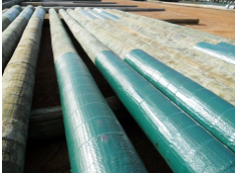
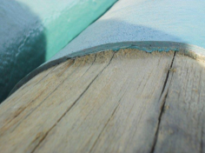

In 2014 another brush fire event occurred in the region where several thousand Nukote FR treated poles had been installed. After government inspection of the area revealed that all Nukote FR treated poles had performed to specification and were still standing. The poles installed prior to Nukote FR implementation were not.

